Jan. 31st to Feb. 3rd : Monday to Thursday
Feb. 7th to Feb. 10th : Monday to Thursday
EARTHQUAKE !! Take Cover !!
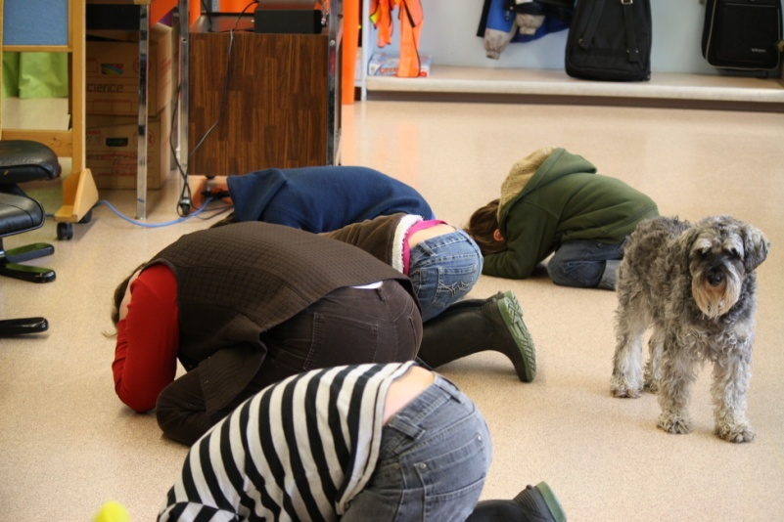
Strong Start and our Elementary class had a very successful Earthquake drill on Wednesday. Everyone got right into the swing of it. We will be well prepared in the event of a real “shake up”.
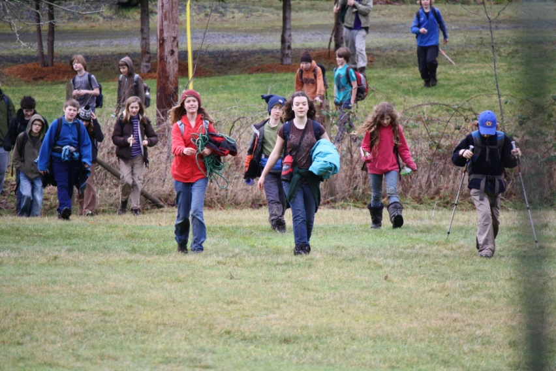
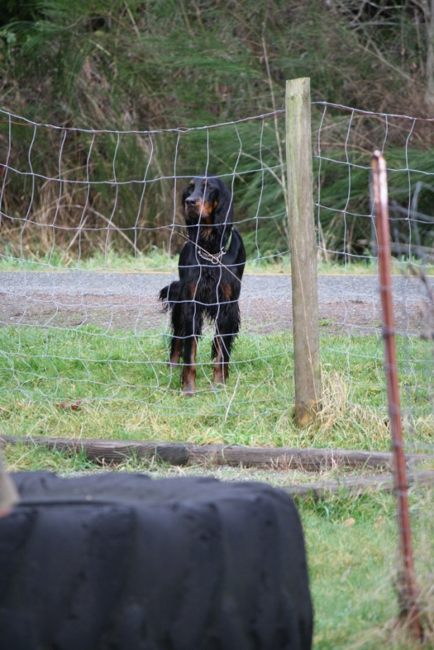
.
Field Trip

Our next Field Trip on Tuesday will involve a visit to the Royal British Columbia Museum. We will be exploring our First Nations heritage once again. Our Grade 4 class (Jacob and Carson) are building a very special diorama about the West Coast first people. They are looking forward to getting ideas from the fantastic model village on display in the First Nations Gallery. Liam and Emerson are working on their own diorama which goes back slightly earlier in our history, to the Jurassic era. Both models are coming along very nicely.

Needed...

Please ask your child to bring any radio controlled or remotely controlled vehicle that makes a noise to school for an interesting new experiment on the “Doplar effect.”
Here's another visitor
SEEC came for a visit

